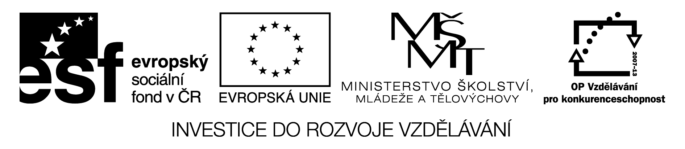

Biography:

You are going to write a biography of a pop, sports or film star. Here are some things that might help you. Work with a partner and do the tasks. Use a dictionary when necessary.

1.There are 3 things you have to do before you start writing. They are mixed up – can you put them in the correct chronological order?

A, Find out basic facts of the person´s life, e.g. date of birth, place of origin, parents, siblings,education,profession,marriage,children, favourite books, music, art, hobbies. Use the Internet, newspapers, magazines, biographies, books.

B, Find out which events shaped your subject´s life, e.g.
- what makes the person special or interesting
- what adjectives would you use to describe the person
- what events changed the person´s life – illness,injury, death,car accident,natural disaster,bad
luck, good luck,child,winning a competition……
- what ( or who ) led to the subject´s success or failure.

C, Select a person you are interested in.

2. Now you can start writing. You should draw a time line of the subject´s life events and put down an outline of your project. Write the sample questions. Add your own if you want.

1.Introduction:

Who/article/about?............................................................................................................
Why/chose/person?...........................................................................................................
What/he or she/do?...........................................................................................................

2. The past/childhood :

When/ born?.....................................................................................................................
Where/born?.....................................................................................................................
Where/he or she/live/before/famous?...............................................................................
Any /siblings?..................................................................................................................
He or she/good/school?....................................................................................................
What/hobbies/have?.........................................................................................................

3. The turning point/fame :

How/become/famous?..............................................................................................................
What/things/do/since/famous?.................................................................................................
He or she/ meet/ somebody/important?...................................................................................

4. Life now/changes :

How/life/change/since/become/famous?.................................................................................
What/do/at the moment?.........................................................................................................
What/ he or she/plan/do/future?..............................................................................................

5. Now you can have a go. But dont´t forget that even Rome wasn´t built in one day. Write a first draft of your biography and take your time . Don´t be afraid to rewrite some passages several times. If possible, ask somebody to read your work to see whether your text makes sence. Check spelling and grammar.
Good luck!

Instrukce:

Životopis

Žáci se připravují k napsání životopisu popové,sportovní či filmové hvězdy. S pomocí učitele procházejí jednotlivé body pracovního listu a diskutují o nich. Pracují ve dvojicích. Používají slovník.

1. Tři základní věci, které před psaním musíš udělat, se promíchaly. Dokážeš je dát do správného pořadí?

2.A, Find out basic facts of the person´s life, e.g. date of birth, place of origin, parents, siblings,education,profession,marriage,children, favourite books, music, art, hobbies. Use the Internet, newspapers, magazines, biographies, books.

3.B, Find out which events shaped your subject´s life, e.g.
- what makes the person special or interesting
- what adjectives would you use to describe the person
- what events changed the person´s life – illness,injury, death,car accident,natural disaster,bad
luck, good luck,child,winning a competition……
- what ( or who ) led to the subject´s success or failure.

1.C, Select a person you are interested in.

2. Teď můžeš začít psát. Načrtni si časovou linii událostí subjektu a napiš si osnovu. Zkompletuj otázky v každé sekci. ( různé možnosti – učitel kontroluje individuálně )
Popřípadě přidej své vlastní otázky.

1.Introduction:

Who/article/about?............................................................................................................
Why/chose/person?...........................................................................................................
What/he or she/do?...........................................................................................................

2. The past/childhood :

When/ born?.....................................................................................................................
Where/born?.....................................................................................................................
Where/he or she/live/before/famous?...............................................................................
Any /siblings?..................................................................................................................
He or she/good/school?....................................................................................................
What/hobbies/have?.........................................................................................................

3. The turning point/fame :

How/become/famous?..............................................................................................................
What/things/do/since/famous?.................................................................................................
He or she/ meet/ somebody/important?...................................................................................

4. Life now/changes :

How/life/change/since/become/famous?.................................................................................
What/do/at the moment?.........................................................................................................
What/ he or she/plan/do/future?..............................................................................................

5. Teď už se můžeš pustit do díla. Nezapomeň ale, že ani Řím nebyl postaven za jeden den. Napiš si nejdříve první koncept a neboj se některé části několikrát přepsat. Pokud možno, dej práci někomu přečíst, zjistíš, zda je dost srozumitelná i pro ostatní. Zkontroluj pravopis a gramatiku. Hodně štěstí!

